Writing Tutor 3A 수정사항

초판본으로 학습하시는 고객님은 아래의 수정사항을 참고해 주세요. 감사합니다.

Unit 1
- Part 2 의 두번째 페이지 (p.19): D 문제의 지시문에 있는 페이지넘버가 p. 8, p. 10 에서 p. 16, p. 18로 바뀌어야 합니다.
즉 여기서 outline 을 위해 참고해야 할 페이지는 해당유닛의 part 1 Listen and Gather Ideas 와 Part 2 Make Your Outline_B 부분입니다.
- Part 4 의 두번째 페이지 (p.27): 맨 아래의 지시문에 있는 pp. 14-15 는 pp. 22-23 으로 바뀌어야 합니다.
즉 여기서 revise 를 위해 참고해야 할 페이지는 해당유닛의 part 3 Complete the 1st Draft 입니다.
- Part 4 의 세번째 페이지 (p.28): Proofread 의 지시문에 있는 pp. 14-15 도 pp. 22-23 으로 바뀌어야 합니다
여기서도 proofread 를 위해 참고해야 할 페이지는 해당유닛의 part 3 Complete the 1st Draft 입니다.

Unit 2
p. 37: p. 26, p. 28 → p. 34, p. 36
p. 45: pp. 32-33 → pp. 40-41
p. 46: pp. 32-33 → pp. 40-41

Unit 3
p. 55: p. 44, p. 46 → p. 52, p. 54
p. 63: pp. 50-51 → pp. 58-59
p. 64: pp. 50-51 → pp. 58-59

Unit 4
p. 73: p. 62, p. 64 → p. 70, p. 72
p. 81: pp. 68-69 → pp. 76-77
p. 82: pp. 68-69 → pp. 76-77

Unit 5
p. 91: p. 80, p. 82 → p. 88, p. 90
p. 99: pp. 86-87 → pp. 94-95
p. 100: pp. 86-87 → pp. 94-95

Unit 6
p. 109: p. 98, p.100 → p. 106, p. 108
p. 117: pp. 104-105 → pp. 112-113
p. 118: pp. 104-105 → pp. 112-113

Unit 1 My Favorite Vacation

Part 1

* Learn about Essay Writing 1
A. 1. A question-the third sentence 2. A fact-the first sentence
3. A quotation-the second sentence

* Listen and Gather Ideas
A. 1. He talks about cities, nature, and a foreign country.
2. They can go swimming or windsurfing at the beach and go hiking or skiing in the mountains.

B.
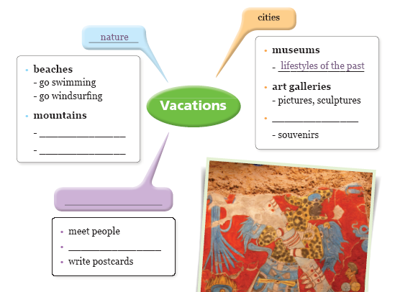
hiking
skiing
local market
exotic food
foreign country

* Grammar Practice 1
A. 1. c 2. a 3. c 4. b 5. b

Part 2

* Make Your Outline
A. dream vacation, What place, Why

* Sample Essay
B. 1. There are two main reasons why I would like to go to London; first, for the historic sites and
second, for the city’s arts and culture.
2. Have you ever been to London? It is for drawing the readers’ interest.

C.
Title: A Place I Would Like to Go

Thesis statement:
There are two main reasons why I would like to go to London: first, for all the historic buildings and, second, for the arts and culture.

Reason 1: For all the historic building there
Example(s): Westminster Abbey, Buckingham Palace, Big Ben

Reasons 2: For the city’s art and culture
Example(s): The British Museum, watch the musical

Part 3

* Learn about Essay Writing 2
A. 1. A Chinese proverb says “He who returns from a journey is not the same as he who left.”
Over 74 million people visit France every year.
2. The attention grabber in the first example is a quotation and the one in the second example
is a fact.
B. 1. b 2. c 3. a

* Grammar Practice 2
A. 1. was 2. will visit 3. relaxed 4. went
B. 1. I often go to the beach to relax.
2. I watched a popular musical in Seoul.
3. Some day, I will visit Egypt with my family.
4. My parents took me to an amusement park last Saturday.

Part 4

* Revise the Sample
B. 1. b 2. a 3. c 4. d
C. 1. b 2. b 3. a 4. a

* Grammar Review
A. 1. writing 2. did 3. looking 4. arrived 5. stopped 6. am
Unit 2 My Favorite Pet

Part 1

* Learn about Essay Writing 1
A. c
B. 1. a, b 2. d

* Listen and Gather Ideas
A. 1. A corn snake is mentioned.
2. They can make you happy and keep you healthy.

B.
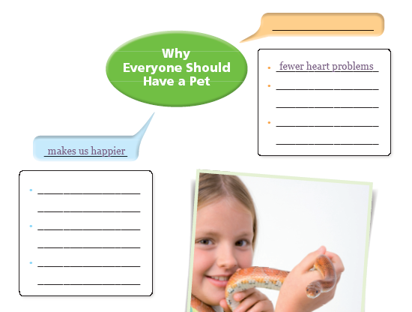
helps keep us healthy
keep us company
entertain us
become like a family
member
fewer allergy problems
better mental health

* Grammar Practice 1
A. 1. a 2. a 3. b 4. a 5. c

Part 2

* Make Your Outline
A. a wild animal you would like to have for a pet, Why

* Sample Essay
B. 1. I would like to have a tiger as a pet for two reasons: A tiger would be attractive, and it could also protect me.
2. “An elephant would be extremely large, and a bear would be just as large—and very smelly.” The writer uses the common opinion about unsuitable animals for pets to tell that his opinion is better.

C.
Title: A Wild Animal for a Pet

Thesis statement: I think the best choice is a tiger. I would like to have a tiger as a pet for two reasons. A tiger would look good and could also protect me.

Reason 1: Tigers are beautiful.
Example(s): They have powerful bodies and strong tails.
Their fur has beautiful stripes.

Reasons 2: A tiger can protect me.
Example(s): They are very strong.
They are scary.

Part 3

* Learn about Essay Writing 2
A. 1. Most people only think of pigs as farm animals.
Most people think of fish as a boring pet.
2. From these general statements, the reader will know what the writer is going to talk about in his or her paragraphs. Also, the reader may be more interested in reading the story because the attention grabbers give an opinion which is unique and different from the general statements.
3. A general statement should show the topic of the paragraph and be closely related to the attention grabber. It should not be too long and help the should not include the summary of the entire essay.
B. d-b-a-c
General statement – Cats are one of the most popular pets the world over. This sentence tells the general information on cats. It does not draw people’s attention, so it is not an attention grabber. It does not have the writer’s main point, so it is not the thesis statement.

* Grammar Practice 2
A. 1. looking 2. bitten 3. jumping 4. named
B. 1. The dog is running after the rabbit.
2. Pets are kept by many people.
3. I have trained my dog for the competition.
4. The cat climbed on the tree.

Part 4

* Revise the Sample
B. 1. c 2. a 3. b 4. d
C. 1. b 2. b 3. b 4. a

* Grammar Review
A. 1. given 2. told 3. licking 4. taken 5. bought 6. sleeping

Unit 3 My Favorite Food

Part 1

* Learn about Essay Writing 1
A. 1. b 2. a 3. a 4. b
B. Abraham Lincoln was a great president because he was a strong leader and an honest man.

* Listen and Gather Ideas
A. 1. It tastes good, gives a good feeling, and good memories.
2. They can make you happy and keep you healthy.

B.
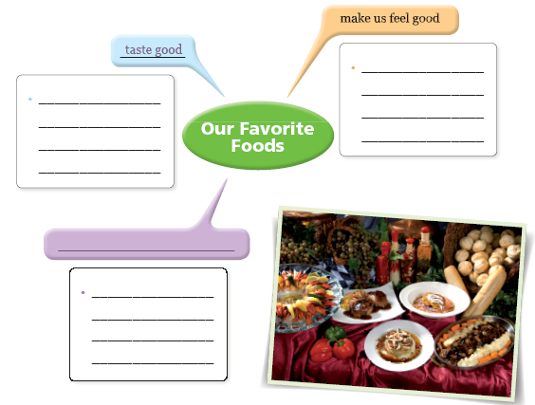
enjoy the taste
makes us happy

chocolate is special
for some people

can remind us of
happy childhood

can give us good memories

* Grammar Practice 1
A. 1. a 2. a 3. b 4. a 5. b

Part 2

* Make Your Outline
A. What, popular food in your country, Why

* Sample Essay
B. 1. Enchiladas are popular for their spicy flavor and different fillings.
2. ”Enchiladas are popular for their spicy and different fillings.” We can expect that an enchilada’s
spicy taste and different fillings are reasons supporting the thesis statement__
C.
Title: A Popular Food in My Country

Thesis statement: Enchiladas are popular for their spicy flavor and different fillings.

Reason 1: An enchilada is spicy.
Example(s): Onions
Chili peppers

Reasons 2: Enchiladas have different types of fillings.
Example(s): Beans, tomatoes, green vegetables, cheese, fruit

Part 3

* Learn about Essay Writing 2
A. 1. Honey ants are a popular food in the Australian Outback because of their sweet flavor
and nutritious content.
2. We will read about the flavor and the nutritious content of honey ants.

B. Good thesis statement: 1,4
Bad thesis statement: 2,3
2: I would never want a spider as a pet because it looks scary and it does not show any feelings.

* Grammar Practice 2
A. 1. to make 2. to find 3. cooking 4. to chew
B. 1. I enjoy cooking.
2. How about having lunch outside?
3. I want to eat grilled chicken with fresh vegetables.
4. I am trying to eat more vegetables and fruit.

Part 4

* Revise the Sample
B. 1. a 2. b 3. c 4. d
C. 1. a 2. b 3. a 4. a

* Grammar Review
A. 1. having 2. cooking 3. to eat 4. eating 5. Wrapping 6. to try

Unit 4 My Favorite Book

Part 1

* Learn about Essay Writing 1
A. Attention grabber – As the famous American writer Mark Twain said, “Books are for people
who wish they were somewhere else.”
General statement – Many people enjoy reading about adventures people experience in different places. Although you do not go to a certain place yourself, you can imagine the people’s lives there by reading about it.
Thesis statementit. I like reading adventure stories for two main reasons: they have exciting stories of people in different places and they encourage me to take chances
B. Suggested new thesis statement – I like reading detective stories because the stories always have challenging cases for me to participate and guess who the criminal is; also detective stories teach the value of truth to the readers.

* Listen and Gather Ideas
A. 1. Some people think electronic books will replace paper books.
2. They give us special pleasure, they can be taken and used anywhere, and they are easier to
read than electronic books.
B
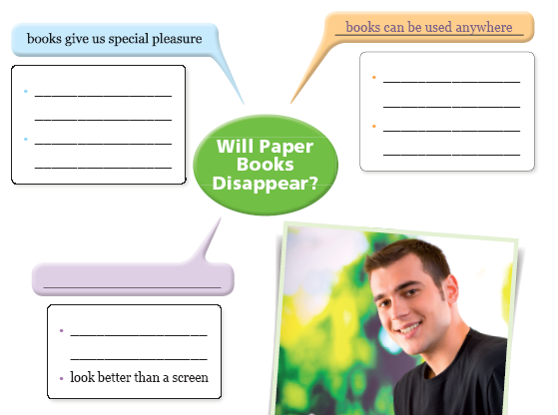
they smell good

they feel good in
our hands
don’t make your eyes tired
books are easier on the eyes
easy to carry

don’t need batteries

* Grammar Practice 1
A. 1. b 2. c 3. a 4. a 5. a

Part 2

* Make Your Outline
A. What genre, Why

* Sample Essay
B. 1. In biographies, I can learn interesting things about famous people and history.
2. The first sentence is to catch the reader’s attention and the last sentence is to answer to the
question.

C.
Title: My Favorite Book Genre

Thesis statement:
In biographies, I can learn interesting things about famous people and history.

Reason 1:
Biographies tell me things about people that I did not know before.
Example(s):
The reasons for the person’s thinking
The reasons for the person’s actions
Interesting things the person said and did

Reasons 2: Biographies teach me about history.
Example(s):
When and where someone was born
The historical events of certain time
The person’s effect on history

Part 3

* Learn about Essay Writing 2
A. Dorothy Sayers: 5-2-1-3-4

B. Many people read books only for studying or getting information.

* Grammar Practice 2
A. 1. chatting 2. to like 3. Reading 4. to check out
B. 1. Reading is so much fun.
2. I love reading mysteries.
3. I am interested in learning a language.
4. My friend advised me to buy that book.

Part 4

* Revise the Sample
B. 1. a 2. c 3. b 4. d
C. 1. b 2. a 3. a 4. b

* Grammar Review
A. 1. to read 2. reading 3. to come 4. to pick 5. to read 6. Making

Unit 5 Why do Earthquakes and Tsunami occur?

Part 1

* Learn about Essay Writing 1
A. A pencil is better for writing than a pen is.
B. 1, 2, 6

* Listen and Gather Ideas
A. 1. An earthquake under the sea causes a tsunami.
2. It can do great damage on land.

B.
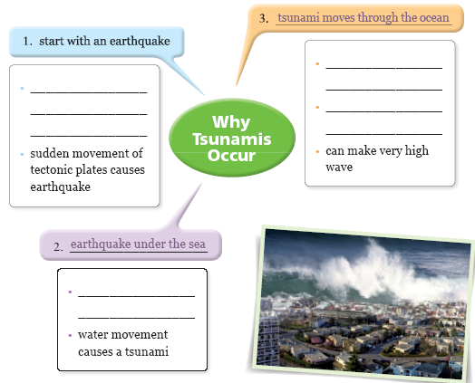
tectonic plates move next to each other
Seperated into fibers
fast in deep water

slow in shallow water
move large amounts of water

* Grammar Practice 1
A. 1. so 2. but 3. Because 4. When 5. Although

Part 2

* Make Your Outline
A. Why, the causes of tsunami

* Sample Essay
B. 1. An earthquake that happens under the ocean can cause a tsunami.
2. The other sentences in the second paragraph are details of how earthquakes underwater lead
to tsunami.

C.
Title: Causes of Tsunamis

Thesis statement: Tsunamis are a result of underwater earthquakes.

Fact 1:
Earthquakes are caused by movement in the plates in the surface of the earth.
Detail(s):
The hot liquid rock in the center of the earth moves.
The floating tectonic plates on the liquid happen to get stuck and unstuck, and that causes earthquakes.

Fact 2: An earthquake underwater can cause a tsunami.
Detail(s):
A tsunami moves at great speed in deep water.
A tsunami it gets into shallow water and becomes dangerous.

Part 3

* Learn about Essay Writing 2
A. a
B. (Suggested answer) Another way of predicting a tsunami is to use a different kind of sensor.

* Grammar Practice 2
A. 1. When 2. and 3. but 4. Although
B. 1. A earthquake happens when plates of the Earth’s crust move together.
2. A deep water tsunami moves fast but a shallow water tsunami moves slowly.
3. If the plates move in opposing directions, the plates will move towards each other.
4. Tsunamis can happen suddenly and can cause a lot of damage.

Part 4

* Revise the Sample
B. 1. a 2. d 3. b 4. c
C. 1. a 2. b 3. b 4. a

* Grammar Review
A. I have made many new friends, and I have learned many things.
The ground shakes very hard, and things fall off of the shelves.
Some people scream, and some people cry.
It was very exciting, but it was scary!
I miss you, and I love you.

Unit 6 How Are Products Made?

Part 1

* Learn about Essay Writing 1
A. 1. a 2. c

* Listen and Gather Ideas
A. 1. It comes from trees.
2. It is cut into chips.

B.
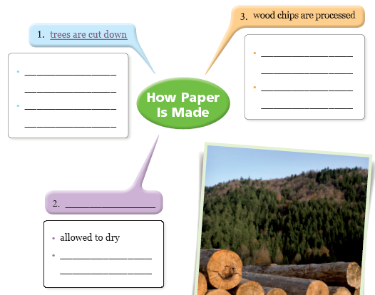
hard wood or softwood
cut into chips
seperated into
fibers
a special liquid is
added
separated into fibers
pressed by rollers
to make paper
fibers sprayed on a screen

* Grammar Practice 1
A. 1. a 2. c 3. b 4. c 5. a

Part 2

* Make Your Outline
A. how, what steps

* Sample Essay
B. 1. First, the tree is cut down and then cut into smaller chips.
2. It explains how to break down the wood to make paper.

C.
Title: How Paper is Made

Thesis statement: Paper is made from wood that is broken down into very small pieces.

Fact 1:
Breaking down some wood to its smallest parts
Detail(s):
the tree is cut down
cut into smaller chips
the chips are put into a liquid that makes the wood separate into fibers

Fact 2: Making a layer of paper
Detail(s):
The wet fibers are sprayed onto a screen in a thin layer and allowed to dry.
The layer is removed and pressed by rollers
The large sheet is cut into smaller pieces

Part 3

* Learn about Essay Writing 2
A. 1. Living in the country is much better than living in the city.
2. There are three supporting sentences.
3. First, Second, Another good thing
B. 1. a 2. c 3. b

* Grammar Practice 2
A. 1. which 2. but 3. that
B. 1. Jeans are casual pants which/that are made from denim.
2. An airbag is a kind of cushion which/that protects people in the car from an accident.
3. Wine is a drink made from grapes, but children should not drink it.
4. More people use headphones these days because they think earphones are bad for their
ears.

Part 4

* Revise the Sample
B. 1. a 2. b 3. c 4. d
C. 1. b 2. b 3. b 4. a

* Grammar Review
A. Yesterday, I went to the stationery store. I bought a pencil case, and I bought some wooden pencils. When I got home, I sharpened the pencils. Then, I put them away. As I was doing that, I dropped one. I didn’t see it on the floor. I stepped on it, and it broke. When I picked up the broken pieces, I could see how the pencil was made. The pencil was split in half, and the lead was sticking out. I saw the grooves that were cut into each side when I pulled the wood apart. The lead fit perfectly into the grooves. I could see that the two pieces of wood had been glued together. I took the metal ring, which held the eraser in place, off of the end of the pencil. Then, I pulled the eraser out. When I finished taking the pencil apart, I wanted to try to glue it back together. I didn’t have any glue, so I had to go back to the stationery store.

