Reading Sprout 3 Review Test (Units 4-6)

Word Sprout
Word Sprout ____________________________________________
Circle the correct answer.

1. a. draw b. breakfast


2. a. van b. bus


Circle the word.

3. s a m e d


4. n o m o v i e

Sentence Sprout
________________________________________________________
Circle the correct answer.
5. Segways __________________ fast.
a. are not b. not are

6. Julie reads ______________________.
a. a bike b. a lot

Write the words in correct order.
7. _______________________ my room.
(clean / will / I)
8. Some people _________________________.
(ride / scooter / a)
Comprehension Sprout
________________________________________________________
Circle the correct answer.


9. Julie and I are the same Yes / No

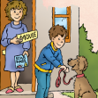

10. You can walk the dog, Mom. Yes / No

Write the correct answer.

11. Some people fly a plane. Planes are __________.

a. slow b. fast

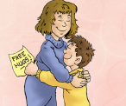
12. I will give you _________________.

a. breakfast b. hugs
SCORE: ______ / 15

