Reading Sprout 3 Review Test (Units 10-12)

Word Sprout
Word Sprout ____________________________________________
Circle the correct answer.


1. a. bag b. back


2. a. foot b. food

Circle the word.
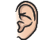

3. r e a r w


4. u w i n g k

Sentence Sprout
________________________________________________________
Circle the correct answer.
5. Your eyes see. My eyes see, __________!
a. and b. too

6. ___________ you like this dress?
a. Do b. What

Write the words in correct order.
7. ___________________ this machine do?
(does / What)
8. _________________________ a dress show.
(to / Let’s / go)
Comprehension Sprout
________________________________________________________
Circle the correct answer.
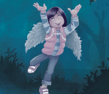

9. My wings are for flying, too! Yes / No

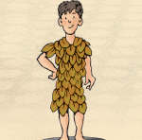
10. It’s a leaf dress. Yes / No

Write the correct answer.
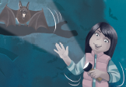
11. Your arms and my arms _________.

a. hear b. bend

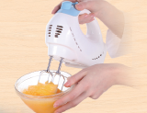
12. This machine ____________ food.

a. cooks b. mixes
SCORE: ______ / 15

