Reading Sprout 3 Midterm Test (Units 1-6)

Word Sprout
Word Sprout ____________________________________________
Write the missing letters.

a r e r i r

1. d _ _ t y

o a o w o u

2. b _ _ t

i e e y a i

3. l _ _

Match the word to the picture.
4. drive • 5. fit • 6. different • 7. kind •




• • • •



Sentence Sprout
________________________________________________________
Choose the correct answer.


8. __________ people ride a bike.
a. No b. Some
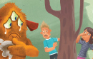
9. Monster, go away! You are ________ dirty.

a. too b. not

Write the words in correct order.
10. We will _________________________________.
(you / play / with)
11. ________________________ carrots.
(like / doesn’t / He)
Comprehension Sprout
________________________________________________________
Choose the correct answer.


12. This story is about ___________________.
a. playing with friends b. good friends
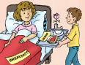

13. This story is about ___________________.
a. sick Mom b. Mother’s day

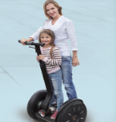
14. Segways are _________________.

a. not fun b. fun

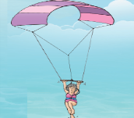
15. Grandma is __________________.

a. in the air b. in the water
SCORE: ______ / 15

