Reading Sprout 3 Final Test (Units 7-12)

Word Sprout
Word Sprout ____________________________________________
Write the missing letters.
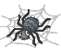
a r e r i r

1. s p i d _ _

b l e p l e t l e

2. t u r _ _ _

e e e a o o

3. l _ _ f

Match the word to the picture.
4. together • 5. bake • 6. eye • 7. food •

• • • •





Sentence Sprout
________________________________________________________
Choose the correct answer.

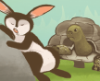
8. “Rabbit, __________ sleep!” says Turtle.
a. let’s b. don’t
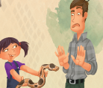
9. Dad, will you play _______ me?

a. with b. for

Write the words in correct order.
10. ________________________________________.
(cooks / food / This machine)
SCORE: ______ / 15
11. ________________________________________?
(you / Do / this dress / like)
Comprehension Sprout
________________________________________________________
Choose the correct answer.


12. This story is about funny ________________.
a. pizza b. ice cream
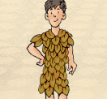

13. This story is about ________________.
a. a dress show b. a model

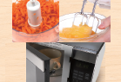
14. We can ____________________ with machines.
a. cut, mix and cook b. see, hear and fly

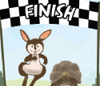
15. ____________________win together!

a. Rabbit and Turtle b. Spider and Snake
SCORE: ______ / 15
SCORE: ______ / 15

