
Reading Sprout 2 Review Test (Units 4-6)

Word Sprout
Word Sprout ____________________________________________
Circle the correct answer.


1. a. break b. skate


2. a. now b. noisy

Circle the word.


3. n u f u n e


4. r o c k e t e

Sentence Sprout
________________________________________________________
Circle the correct answer.
5. I see ________________.
a. things many b. many things

6. We ______________________.
a. have fun b. can fun

Write the words in correct order.
7. _________________________, Grandfather!
(not / Do / sleep)
8. They fly _______________________.
(the / in / sky)
Comprehension Sprout
________________________________________________________
Circle the correct answer.


9. I see airplanes. Yes / No

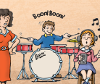
10. It is not noisy. Yes / No

Write the correct answer.
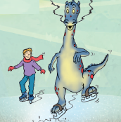
11. He ___________ skate. He breaks the ice.

a. can b. can’t

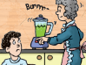
12. Do not _______________, Grandmother.

a. cook b. clean
SCORE: ______ / 15

