
Reading Sprout 2 Review Test (Units 10-12)

Word Sprout
Word Sprout ____________________________________________
Circle the correct answer.
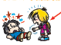

1. a. bad b. bird


2. a. write b. watch

Circle the word.


3. s m u s i c s


4. e r l a u g h

Sentence Sprout
________________________________________________________
Circle the correct answer.
5. I ____________________ a phone.
a. have b. cry

6. _______________ be scared.
a. Let’s b. Don’t
Write the words in correct order.
7. _________________________ books.
(don’t / I / like)
8. Mom _________________________.
(small / feet / has)
Comprehension Sprout
________________________________________________________
Circle the correct answer.

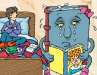
9. Book Monster is reading and crying. Yes / No


10. Grandfather writes e-mails. Yes / No

Write the correct answer.
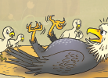
11. Oh, the big bird is _____________ .

a. dad b. mom

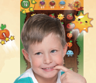
12. I ___________________ on my dad’s phone.

a. play a game b. talk
SCORE: ______ / 15

