
Reading Sprout 2 Midterm Test (Units 1-6)

Word Sprout
Word Sprout ____________________________________________
Write the missing letters.
a e i

1. s k _ t _
s h c h c k

2. t e a _ _ e r
b r f r g r

3. _ _ a n d m o t h e r

Match the word to the picture.
4. rain • 5. helicopter • 6. backpack • 7. sing •

• • • •


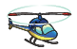


Sentence Sprout
________________________________________________________
Choose the correct answer.


8. _____________ clean the room.
a. Not b. Do not


9. He ______________ play games.

a. can b. let’s

Write the words in correct order.
10. __________________________. They fly in the sky.
(airplanes / I / see)
11. Do not cook. ______________________________!
(It / too / is / noisy)
Comprehension Sprout
________________________________________________________

Choose the correct answer.

12. This story is about walking _______________.
a. in the rain b. in the sky
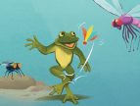

13. This story is about playing ________________.
a. with a pet b. with friends


14. My pencil says, “________________!”

a. Wake up b. Play with me

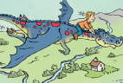
15. My pet ___________ can fly.

a. dragonfly b. dragon
SCORE: ______ / 15

