Reading Sprout 2 Final Test (Units 7-12)

Word Sprout
Word Sprout ____________________________________________
Write the missing letters.
a l l o o l o o r

1. d _ _ _
f l p l c r
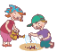
2. _ _ a n t
o i o y u i

3. v _ _ c e

Match the word to the picture.
4. small • 5. basket • 6. scared • 7. phone •





• • • •

Sentence Sprout
________________________________________________________
Choose the correct answer.

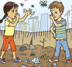
8. There _______________ cans and bottles.
a. are b. too
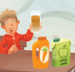
9. _____________ capple juice, Dad!

a. We will b. Here is

Write the words in correct order.
10. ___________________ to hide.
(time / is / It)
SCORE: ______ / 15
11. ___________________________ now!
(the / Open / door)
Comprehension Sprout
________________________________________________________
Choose the correct answer.


12. This story is about ________________.
a. reading b. a friend
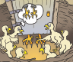

13. This story is about ________________.
a. baby birds and Mom b. voice and feet


14. We can ________________ on our phones.
a. do many things b. only talk

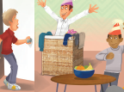
15. _______________my birthday. But thank you!

a. It’s b. It’s not
SCORE: ______ / 15
SCORE: ______ / 15
SCORE: ______ / 15
SCORE: ______ / 15
SCORE: ______ / 15
SCORE: ______ / 15

