
Reading Sprout 1 Review Test (Units 7-9)

Word Sprout
Word Sprout ____________________________________________
Circle the correct answer.

1. a. trash b. talk

2. a. fly b. fall

Cross out the wrong letter.

3. p a i p e r
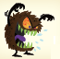
4. m o n g s t e r

Sentence Sprout
________________________________________________________
Circle the correct answer.
5. We ____________________ onions.
a. fall b. love

6. ____________________ a robot?
a. Is this b. I am
Write the words in correct order.
7. Now _________________________.
(are / trashgirls / you)
8. ____________________, too.
(can / It / fall)
Comprehension Sprout
________________________________________________________
Circle the correct answer.
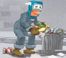
9. I throw people’s trash away. Yes / No

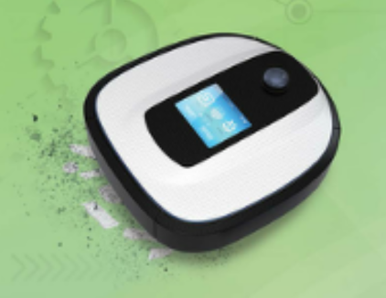
10. This is a robot. It can clean. Yes / No

Write the correct answer.
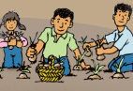
11. We all _____________ onions.

a. grow b. sell

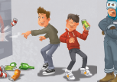
12. I see _____________________.

a. cans and bottles b. paper and glass
SCORE: ______ / 15

