
Reading Sprout 1 Review Test (Units 10-12)

Word Sprout
Word Sprout ____________________________________________
Circle the correct answer.
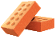

1. a. brick b. stick


2. a. leaves b. beans

Circle the word.
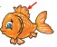

3. f n f i n
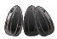

4. c s e e d t

Sentence Sprout
________________________________________________________
Circle the correct answer.
5. I will ____________________ a house.
a. eat b. build

6. What will ____________________ ?
a. come next b. next come

Write the words in correct order.
7. No one _________________________.
(my / body / likes)
8. I have ____________________.
(sprouts / two)
Comprehension Sprout
________________________________________________________
Circle the correct answer.

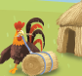
9. I will build a house of sticks. Yes / No


10. Now I have beans! Yes / No

Write the correct answer.
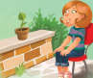
11. I watch and _____________ .

a. wait b. eat up

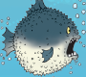
12. I am a ___________________ .

a. round fish b. sad shark
SCORE: ______ / 15

