Reading Sprout 1 Final Test (Units 7-12)

Word Sprout
Word Sprout ____________________________________________
Write the missing letters.
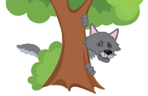
i e y

hide pic
1. h _ d _

s h s p s t

stripes pic
2. _ _ r i p e s

birthday pic
3. b i r t h d _ _
a i a y o o

Match the word to the picture.
4. soup • 5. paint • 6. scared • 7.puppy •



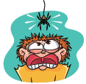
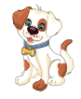
• • • •
soup pic
scared
paint pic

________________________________________________________
Sentence Sprout
Choose the correct answer.
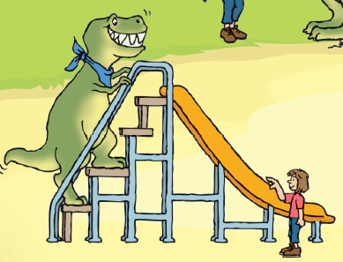
8. She ________________ .
Dino can climb pic
a. can climb b. can ride

9. Sorry, I can’t come. I’m ________________ .
cooking pic
a. painting b. cooking
Write the words in correct order.
10. Can you ___________________________?
(fly / make / soup)
11. My _______________________________.
(T-shirt / spots / has)
Comprehension Sprout
___________________________________________________
Choose the correct answer.
playing ghosts pic
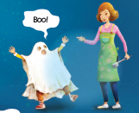
12. This story is about _______________.
a. ghosts b. wheels
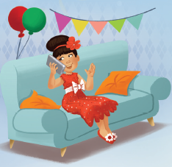
the party pic
13. This story is about ________________.
a. my friends b. my birthday
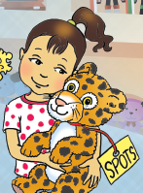

14. Kim ________________!
a. gets Spots b. gets Stripes
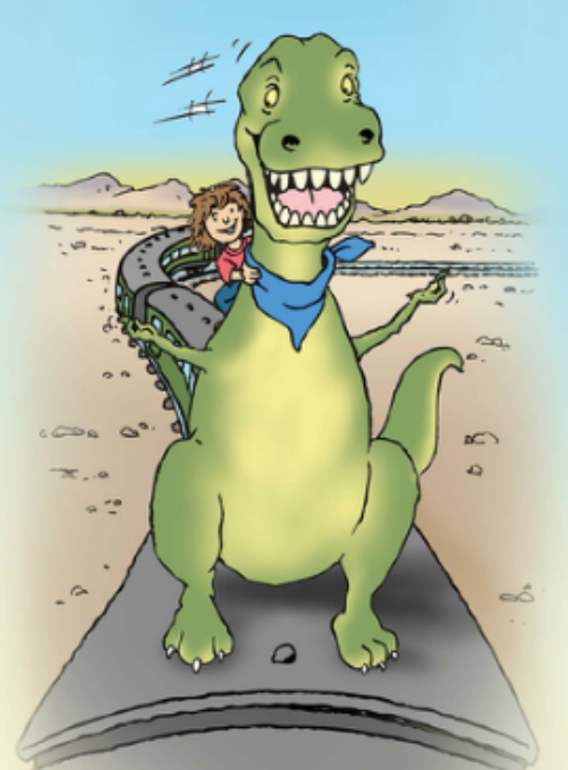
15. My pet dinosaur _______________!
a. can hide b. can ride
SCORE: ______ / 15

