Reading Sprout 1 Final Test (Units 7-12)

Word Sprout
Word Sprout ____________________________________________
Write the missing letters.
a y o u o w

1. s p r _ _ t

b r g r t r

2. _ _ o w
e a e e o w

3. c l _ _ n

Match the word to the picture.
4. build • 5. teeth • 6. onion • 7. bottle •

• • • •





Sentence Sprout
________________________________________________________
Choose the correct answer.

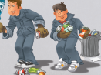
8. _______________throw the trash away.
a. Supertrashmen b. Boys
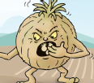
9. The onion monster ________________.

a. sells onions b. loves onions

Write the words in correct order.
10. A robot ______________________________.
(make / cars / can)
11. Now I _______________________________.
(have / flowers / four)
Comprehension Sprout
________________________________________________________
Choose the correct answer.

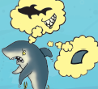
12. This story is about ________________.
a. a happy shark b. a sad shark
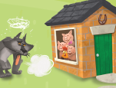

13. This story is about ________________.
a. houses b. animals

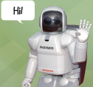
14. Robots can ________________.

a. talk and fly b. grow and eat


15. I will ____________________!

a. sell beans b. eat beans
SCORE: ______ / 15

