I. Outline

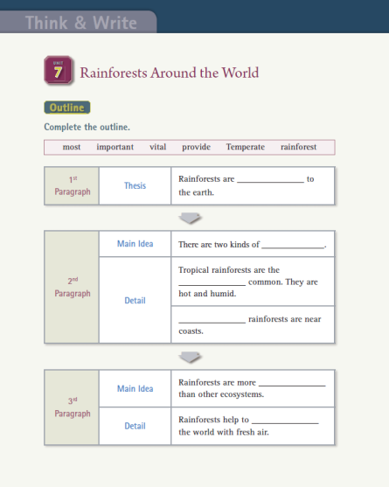
The Outline distinguishes the difference between the Main Idea as well as the Details of the text. This is the main point of reading comprehension. The reader is trained to use the main theme to help systemize more detailed information regarding the text.
The Detail is a key component that supports the Main Idea. When reading the Text, we help the student distinguish between the Main Idea and the Details. We also show them that the Details serve as the foundation for the Main Idea.

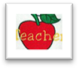To distinguish the Main Idea, practicing with Topics first is very helpful.

Providing students with short sentences and asking them to distinguish between the Main Idea and the Details will provide them with the skill to distinguish the Main Idea in longer texts as well.
e.g

Activity tips for thinking skills

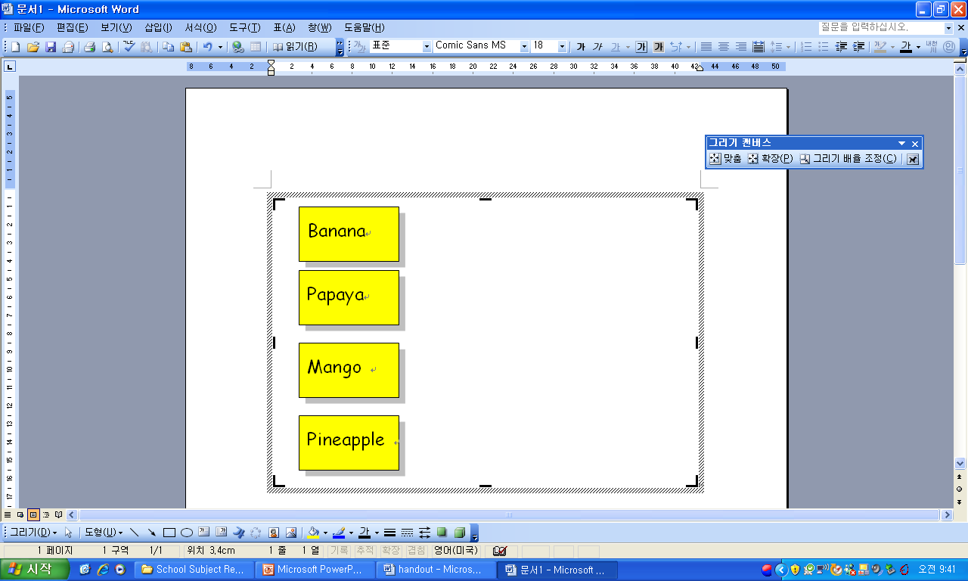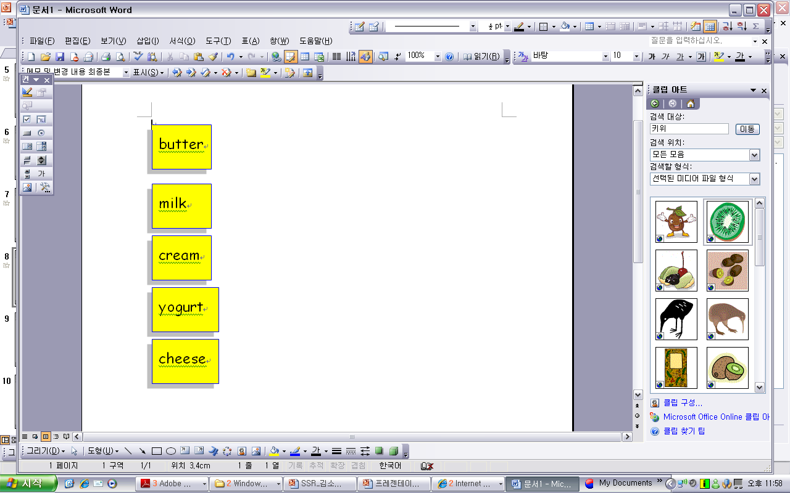
Provide a word list for the students and help them find a common concept from the list. By finding the concepts of ‘tropical fruit’ and ‘dairy product’, students can naturally understand what a topic is.

The Fish Bone Graph also helps students distinguish between the Main Idea and the Details. Use a sentence that relates to a student’s life. e.g. Give “My mom is a good cook” as the Main Idea and ask for supporting details, like the best dishes that she cooks
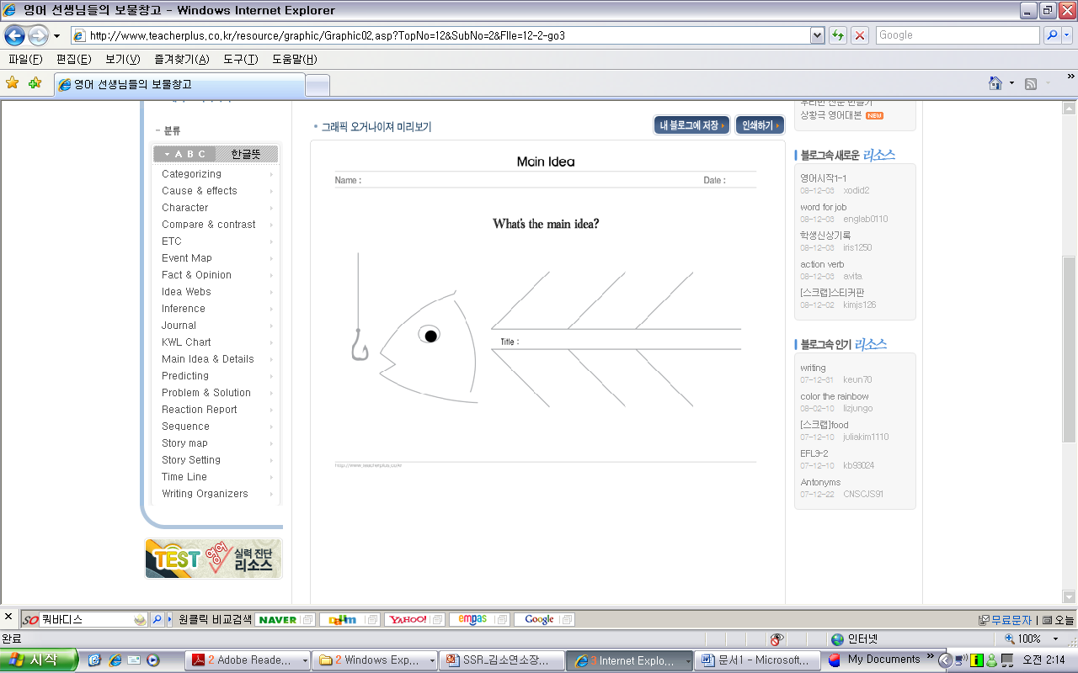

All mammals are the same in certain ways. They all have lungs, hair or fur, and the ability to nurse their young.

II. Sequence

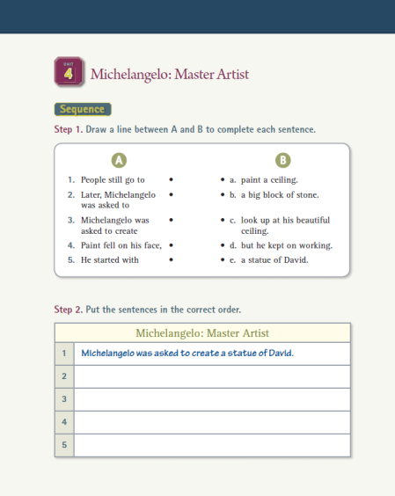
Sequencing refers to distinguishing the time order of events in a text. With this time order, students can determine how the events relate to another by drawing out a Cycle.

With this Reading Skill, students can understand the Details, and they can also understand the text from beginning, middle, and end. They also remember the text as a whole, and not in pieces. Eventually they can also understand the author’s intentions.
,

Distinguish between the main components of the story: (beginning, middle, end), and with the correct sequence of events, students can retell the text.
- Select a familiar story like a fairy tale or a fable.
- When students start to read, remind them that this activity is to improve their Sequencing skills.
- When students read, they should have a paper and a pencil to write the main pages and expressions that will remind them of the events in the story.
e.g.

- The written list should not include the entire story, but it should include the main points. These points will help students retell the story.
- After reading the story, have students sequence the story, and present their stories.
Activity tips for thinking skills

<Cinderella>
Cinderella cleaned the floor.
The Fairy Godmother helped her go to the ball.
The Prince danced with Cinderella.
Cinderella tried on the glass slipper. It fit!

- Compare & Contrast

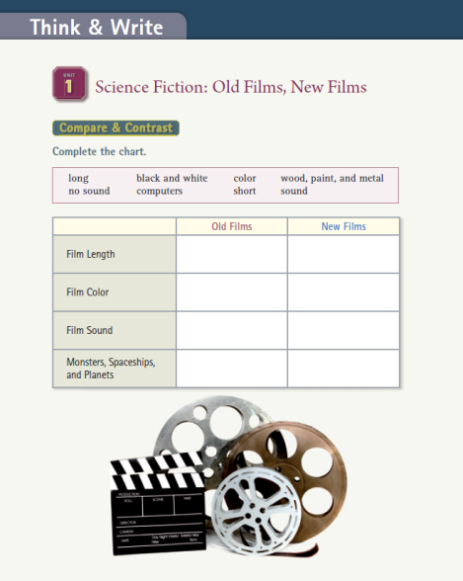
In the Compare & Contrast section, students choose two sections and find the differences and similarities for each point.

With this Reading Skill, students are taught to distinguish the similarities and differences by looking at the format and the information that is provided in the text.

It is a difficult task to compare long descriptions in a text. It is important to train this Reading Skill with short texts like the one below. Therefore, it is important to use easy sentences that can be easily compared and analyzed.
e.g.

- Students read the text.
- Students look for the Clue word, and circle “however” and “both”.
- A Venn Diagram serves as a visual organizer for distinguishing similarities and differences.

- Use the following sentences to ask about the activity: “What are the two main points of the paragraph? How are they the similar? How are they different?”
Activity tips for thinking skills

Hawks and crocodiles are wild animals. Hawks are warm blooded; however, crocodiles are cold blooded. Eagles and crocodiles both lay eggs.

Ⅳ. Cause & Effect

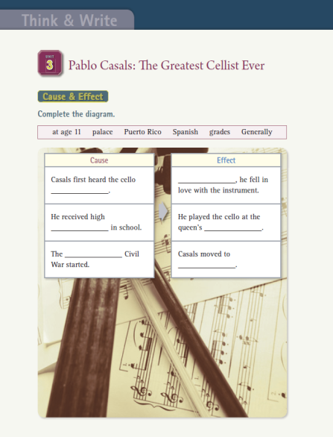
The Cause & Effect section shows what happened, why something happened, and the result of what happened.

Like we know not to eat smelly food or touch a hot object without experiencing it personally, with this Reading Skill, students will have the ability to find the unspecific causes as well as the effects of the text.

To practice with the concept of Cause & Effect, make an artificial set-up in the classroom. For example, drop a basket filled with pencils on the ground, and ask the students what happened. Then ask them why the basket fell. If the students say the basket fell because it was pushed, explain that when one action can cause another action to happen it is known as a “Cause”. And what happens as the result of this “Cause” is an “Effect.”
Write these sentences on the white board.
- It snowed a lot so the old ladies stayed inside.
- Since her shirt was dirty, she washed it.
- Betty was tired this afternoon because she stayed up last night.
Underlining the Causes in red, and the Effects in blue allow students to practice seeing the relationship between Causes and Effects. The signal words reinforce and establish the relationship between Cause and Effect as well. .

Activity tips for thinking skills

so since because as a result consequently

Ⅴ. Problem & Solution
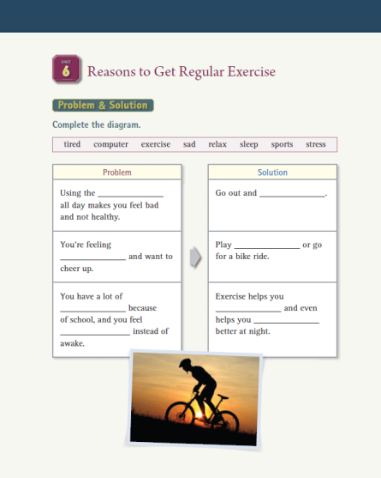
The Problem & Solution section refers to the problem in an event, the cause of the problem, and the solution to that problem.

To improve this Reading Skill, not only must the cause and result be inferred, but the reader must be able to distinguish between Fact and Opinion.

To distinguish between the Problem and the Solution, it is important to focus on the following 4 main points. These points are: i. identifying the problem, ii. listing the consequences of that problem, iii. isolating the causes, iv. proposing the solution to the problem.
It is important to organize these with a visual organizer. Students can use problems they have in the class or personal problems to analyze and practice this skill. (e.g. The efficiency of using English during break, or the delay in homework checks)

What is the Problem?
What are the Effects?
What are the Causes?
What are Some Solutions?

Activity tips for thinking skills

Problem & Solution Chart

Ⅵ. Summary
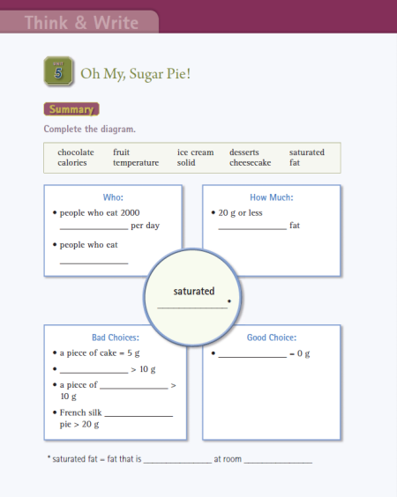
The Summary includes the story’s main elements (background, characters, events, and conclusion). It also organizes the information in the passage and guides the student to a comprehensive understanding of the passage.
The Summary is not a basic retelling of the text. The Summary analyzes the information and distinguishes between the important and less important points and condenses them into concise systematic sentences.

For the Summary of a story, it is important to draw a story map of the characters, background, events, and the conclusion. For Non-fiction text it is important to distinguish between the main points and the subsidiary information.
Use the following steps for the Summary of a Non-fiction text.
- For a general idea of the Topic, quickly skim the text.
- Erase the less important elements or information in the Text.
- Find the Main Idea of the Text and mark it.
- Words with important information about the Main Idea must be marked. These words should be marked in relation to the main idea. Use signal words like, therefore, in conclusion, in summary.
- Lastly, read the text and make a summary again. The main idea of the text should be the first sentence. Make sure to include important information in this first sentence. The students should be warned that the summary should not include personal opinions or be copied word for word from the text.
Activity tips for thinking skills

