First Nonfiction Reading Book 3
Review Test 1 (Unit 1-4)
Name | ___________________ | Score | __________ /_________

A. Match the words with the correct pictures.
1. |  | · |  | · a. subway
2. | 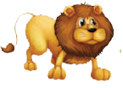 | · |  | · b. snail
3. | 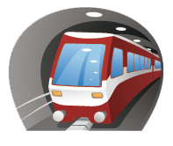 | · |  | · c. lion
4. | 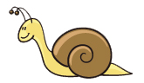 | · |  | · d. wizard
5. |  | · |  | · e. penguin

B. Choose the right sentence.
6. | You need a subway ticket.
6. | a. |  | b.
7. | I’m acting like a knight on a horse.
7. | a. |  | b.

C. Match and make the right sentence.
8. |  | You need | · |  | · a. a bus card.
9. | 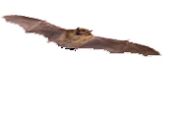 | We see | · |  | · b. snails slow?
10. |  | Are | · |  | · c. the bats.
First Nonfiction Reading Book 3
Review Test 2 (Unit 5-8)
Name | ___________________ | Score | __________ /_________
A. Write the correct word.
towel
butter
umbrella
pumpkin
shorts
1. | 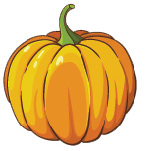
2. | 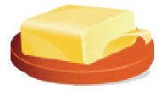
3. | 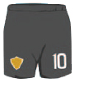
4. | 
5. | 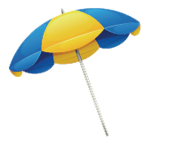
B. Choose the right sentence.
6. | Why do we have this umbrella?
6. | a. |  | b. | 
7. | We need to buy some spices.
7. | a. |  | b.

C. Match and make the right sentence.
8. | 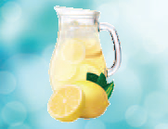 | We have it | · |  | · a. because it’s a hot day.
9. |  | We need to | · |  | · b. to buy a pumpkin.
10. | 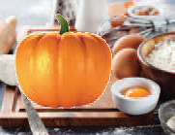 | We need | · |  | · c. buy some sugar.

First Nonfiction Reading Book 3
Review Test 3 (Unit 9-12)
Name | ___________________ | Score | __________ /_________

A. Match the words with the correct pictures.
1. | 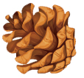 | · |  | · a. game
2. | 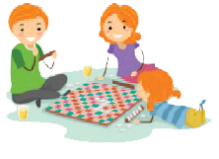 | · |  | · b. sponge
3. | 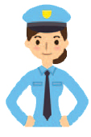 | · |  | · c. pine cone
4. | 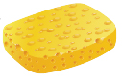 | · |  | · d. police officer
5. | 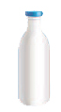 | · |  | · e. milk

B. Choose the right sentence.
6. | The chickens give us eggs.
6. | a. |  | b.
7. | I have a rubber ducky.
7. | a. | 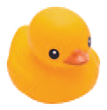 | b. | 

C. Match and make the right sentence.
8. | 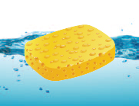 | It floats | · |  | · a. in a restaurant.
9. |  | I give | · |  | · b. in the water.
10. |  | She works | · |  | · c. the cow food.
First Nonfiction Reading Book 3
Review Test 4 (Unit 13-16)
Name | ___________________ | Score | __________ /_________
A. Write the correct word.
pizza
running race
trumpet
sunny
night
1. | 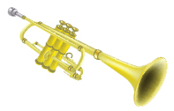
2. | 
3. | 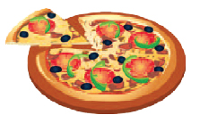
4. | 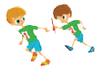
5. | 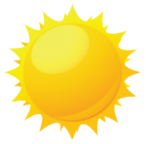
B. Choose the right sentence.
6. | Let’s sing Happy Birthday together.
6. | a. |  | b.
7. | We have to jump high.
7. | a. |  | b.

C. Match and make the right sentence.
8. |  | She plays | · |  | · a. the piano.
9. |  | There’s a | · |  | · b. to wake up.
10. |  | It’s time | · |  | · c. tug-of-war game.

First Nonfiction Reading Book 3
Review Test

Review Test 1
A. Match the words with the correct pictures.
1. e
2. c
3. a
4. b
5. d

B. Choose the right sentence.
6. b
7. b

C. Match and make the right sentence.
8. a
9. c
10. b

Review Test 2
A. Write the correct word.
1. pumpkin
2. butter
3. shorts
4. towel
5. umbrella

B. Choose the right sentence.
6. a
7. b

C. Match and make the right sentence.
8. a
9. c
10. b

Review Test 3
A.
1. c
2. a
3. d
4. b
5. e

B. Choose the right sentence.
6. a
7. a

C. Match and make the right sentence.
8. b
9. c
10. a

Review Test 4
A. Write the correct word.
1. trumpet
2. night
3. pizza
4. running race
5. sunny

B. Choose the right sentence.
6. b
7. a

C. Match and make the right sentence.
8. a
9. c
10. b

