First Nonfiction Reading Book 3
Midterm Test (Unit 1-8)
Name | ___________________ | Score | __________ /_________
A. Match the words with the correct pictures.
1. | 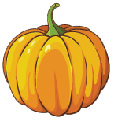 | · |  | · a. pumpkin
2. | 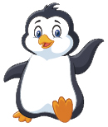 | · |  | · b. lemonade
3. | 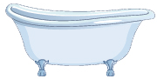 | · |  | · c. bathtub
4. | 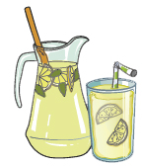 | · |  | · d. penguin

B. Write the right words.
snail
bat
shorts
alien
5. | 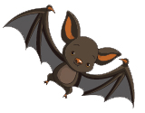 |  | 6. | 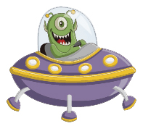

7. | 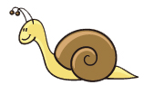 |  | 8. | 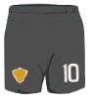
C. Choose the right sentence.
9. |  | You need your bike helmet.
9. |  | You need some money.
10. |  | Snails are slow.
10. |  | Koalas are slow.

D. Write the words in the order.
11. |  | buy  need to  We  some butter.

12. |  | like  I’m acting  pirate.  a

13. |  | in  the bathtub.  look  I

E. Read and answer
We’re at the beach today.

Why do we have this umbrella?
We have it because the sun is hot.

Why do we have these towels?
We have them because the water is cold.

Why do we have this mat?
We have it because the sand is hot.
Why do we have this cold lemonade?
We have it because it’s a hot day.

Can I have some, please?
Ahh . . . that’s fresh!

14. What is the story about?
a. At the jungle
b. At the beach

15. Do we have towels?
a. Yes, we have.
b. No, we don’t.

16. What do we have for the hot sand?
a. We have a mat.
b. We have an umbrella.

First Nonfiction Reading Book 3
Midterm Test (Unit 1-8) Answer Key

A. Match the words with the correct pictures.
1. a
2. d
3. c
4. b

B. Write the right words.
5. bat
6. alien
7. snail
8. shorts

C. Choose the right sentence.
9. |  | You need your bike helmet.
9. |  | You need some money.
10. |  | Snails are slow
10. |  | Koalas are slow.

D. Write the words in the order.
11. We need to buy some butter.
12. I’m acting like a pirate.
13. I look in the bathtub.

E. Read and answer
14. b
15. a
16. a

