First Nonfiction Reading Book 3
Final Test (Unit 9-16)
Name | ___________________ | Score | __________ /_________
A. Match the words with the correct pictures.
1. | 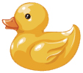 | · |  | · a. tug-of-war
2. | 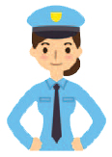 | · |  | · b. rubber ducky
3. | 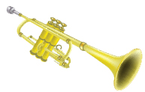 | · |  | · c. trumpet
4. | 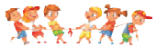 | · |  | · d. police officer

B. Write the right words.
night
wool
violin
sponge
5. | 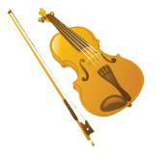 |  | 6. | 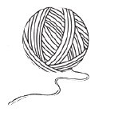

7. | 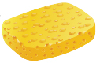 |  | 8. | 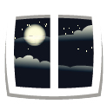
C. Choose the right sentence.
9. |  | It is time to wake up.
9. |  | It is time to eat dinner.
10. |  | She plays the piano.
10. |  | She plays the violin.

D. Write the words in the order.
11. |  | in  works  She  a school.

12. |  | a ball  There’s  throwing contest.

13. |  | songs.  want to  sing  I

E. Read and answer
I like to help out on the farm.
I give the animals food in the barn.

What do the animals give us?
I give the lambs food.
The lambs give us wool.

I give the cows food.
The cows give us milk.

I give the chickens food.
The chickens give us eggs.

I give the donkeys food.
The donkeys give us help.

We can work together.
Thank you!

14. What is the story about?
a. Farm animals
b. Wild animals

15. Do the cows give us eggs?
a. Yes, they are.
b. No, they aren’t

16. What do we give the donkeys?
a. We give the food.
b. We give them help.

First Nonfiction Reading Book 3
Final Test (Unit 9-16) Answer Key

A. Match the words with the correct pictures.
1. b
2. d
3. c
4. a

B. Write the right words.
5. violin
6. wool
7. sponge
8. night

C. Choose the right sentence.
9. |  | It is time to wake up.
9. |  | It is time to eat dinner.
10. |  | She plays the piano.
10. |  | She plays the violin.
D. Write the words in the order.
11. She works in a school.
12. There’s a ball throwing contest.
13. I want to sing songs.

E. Read and answer
14. a
15. b
16. a

