


Answer Key

Unit 1 In the City
Comprehension
1. | a. how to go places
2. | a. subway
3. | a. cross the street
Key Words Practice
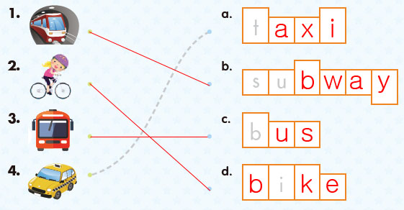
Sentence Practice
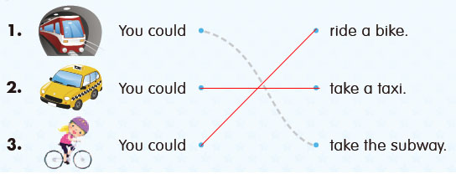
Unit 2 A Day at the Zoo
Comprehension
1. | b. zoo
2. | b. penguins
3. | a. They eat
Key Words Practice
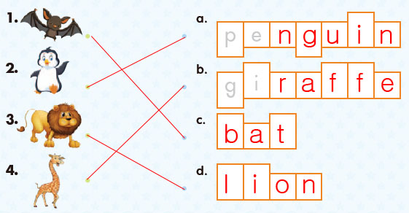
Sentence Practice
1. | 2-1-3 | What do lions like to eat?
2. | 1-3-2 | What do giraffes like to eat?
3. | 3-2-1 | What do penguins like to eat?

Unit 3 A School Play
Comprehension
1. | a. school play
2. | a. pirate
3. | a. helmet
Key Words Practice
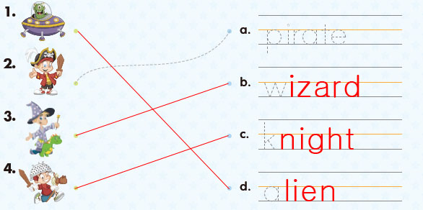
Sentence Practice
1. | a. I have a helmet.
2. | a. I’m acting like a pirate on a ship.
3. | b. I’m acting like a wizard on a dragon.

Unit 4 Fast or Slow
Comprehension
1. | a. fast and slow animals
2. | b. koalas
3. | b. aren’t
Key Words Practice
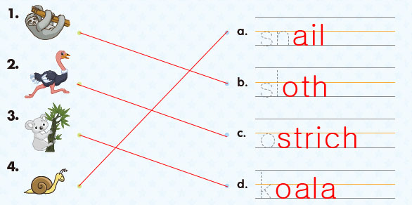
Sentence Practice
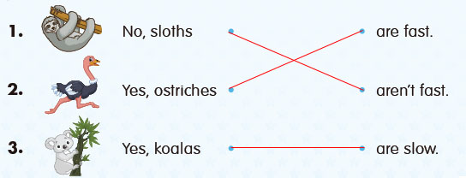

Unit 5 Pumpkin Pie
Comprehension
1. | a. making pie
2. | a. spices
3. | a. Let’s make
Key Words Practice
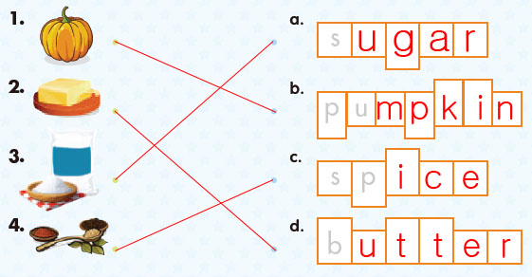
Sentence Practice
1. | 2-1-3 | We need a pumpkin.
2. | 3-2-1 | We need some butter.
3. | 1-3-2 | We need some sugar.

Unit 6 Hide and Seek
Comprehension
1. | a. playing
2. | a. couch
3. | a. I look
Key Words Practice
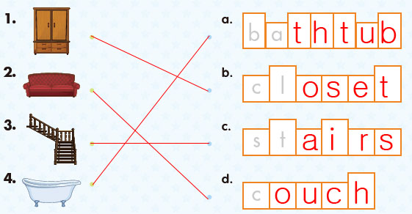
Sentence Practice
1. | a. I look in the closet.
2. | b. I look behind the couch.
3. | a. I look under the stairs.

Unit 7 At the Beach
Comprehension
1. | b. beach
2. | b. this mat
3. | a. cold
Key Words Practice
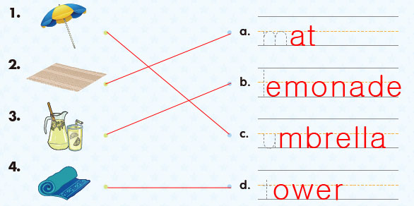
Sentence Practice
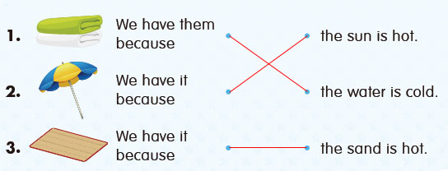
Unit 8 Soccer Clothes
Comprehension
1. | a. clothes
2. | b. shoes
3. | b. number ten
Key Words Practice
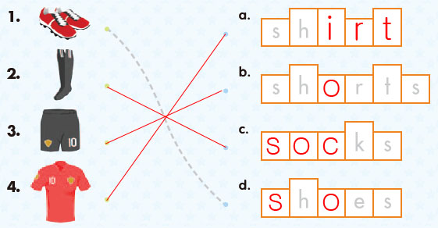
Sentence Practice
1. | 3-1-2 | I’m wearing red shoes.
2. | 1-3-2 | I’m wearing black socks.
3. | 2-1-3 | I’m wearing a black and red shirt.

Unit 9 Sink or Float
Comprehension
1. | a. water
2. | a. rock
3. | a. I have
Key Words Practice
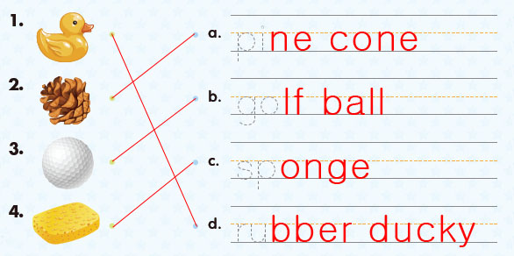
Sentence Practice
1. | a. I have a sponge.
2. | b. I have a pine cone.
3. | b. I have a rubber ducky.

Unit 10 On the Farm
Comprehension
1. | b. farm animals
2. | a. lambs
3. | a. help
Key Words Practice
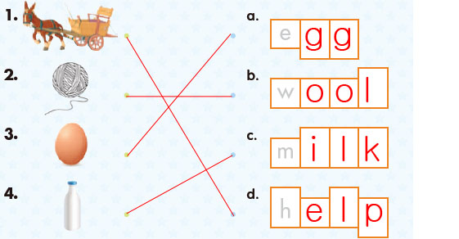
Sentence Practice
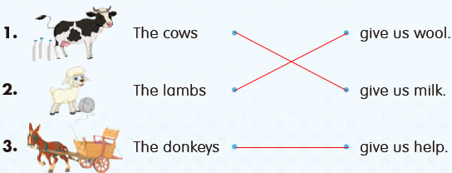
Unit 11 Mom’s Job
Comprehension
1. | a. jobs
2. | b. hospital
3. | b. in a restaurant
Key Words Practice
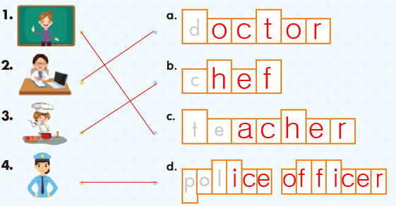
Sentence Practice
1. | 2-1-3 | My mom is a police officer.
2. | 1-3-2 | My mom is a doctor.
3. | 3-2-1 | My mom is a chef.

Unit 12 Birthday Party
Comprehension
1. | b. birthday party
2. | b. pizza
3. | a. Happy Birthday
Key Words Practice
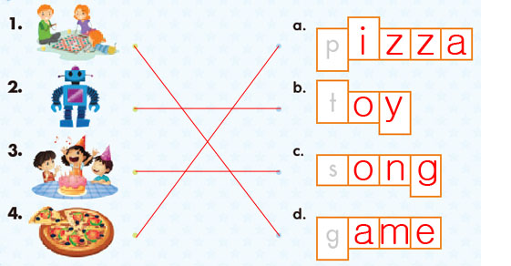
Sentence Practice
1. | b. I want to play games.
2. | b. I want to eat pizza.
3. | a. I want to sing songs.

Unit 13 Sports Day
Comprehension
1. | b. playing sports
2. | a. run
3. | a. hardest
Key Words Practice
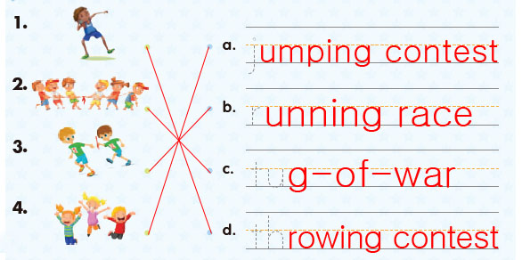
Sentence Practice
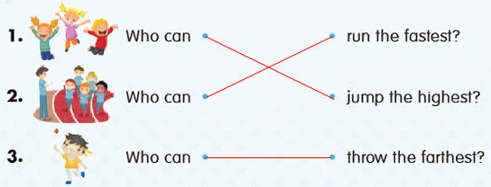
Unit 14 Our Band
Comprehension
1. | b. our band
2. | b. our band
3. | b. trumpet
Key Words Practice
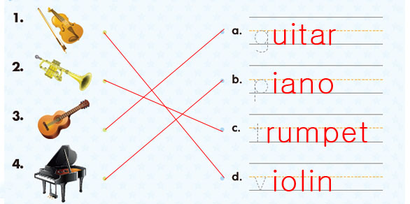
Sentence Practice
1. | 3-2-1 | She plays the piano.
2. | 2-1-3 | He plays the guitar.
3. | 1-3-2 | She plays the violin.

Unit 15 Up and Down
Comprehension
1. | a. up and down
2. | b. leaves
3. | a. goes up
Key Words Practice
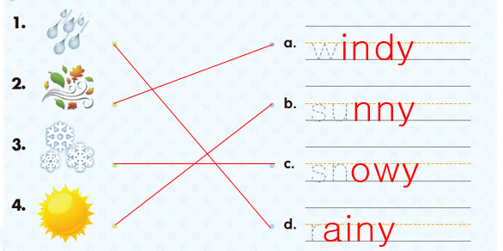
Sentence Practice
1. | a. My kite goes up.
2. | a. The leaves come down.
3. | a. My umbrella goes up.

Unit 16 What Time Is It?
Comprehension
1. | b. time
2. | a. eight o’clock
3. | b. go to sleep
Key Words Practice
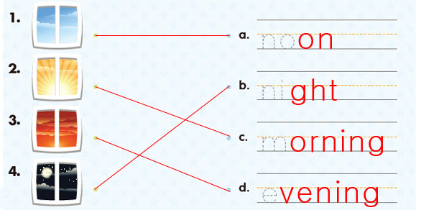
Sentence Practice
