First Nonfiction Reading Book 2
Review Test 1 (Unit 1-4)
Name | ___________________ | Score | __________ /_________

A. Match the words with the correct pictures.
1. |  | · |  | · a. climbing net
2. | 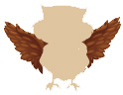 | · |  | · b. door
3. | 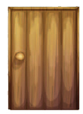 | · |  | · c. roof
4. | 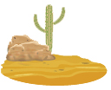 | · |  | · d. long
5. | 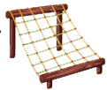 | · |  | · e. desert

B. Choose the right sentence.
6. | Let’s play on the spring horses.
6. | a. |  | b.
7. | Let’s draw a window.
7. | a. |  | b.

C. Match and make the right sentence.
8. |  | Let’s travel | · |  | · a. good ears.
9. |  | They have | · |  | · b. fly very well.
10. |  | They can | · |  | · c. to the jungle.
First Nonfiction Reading Book 2
Review Test 2 (Unit 5-8)
Name | ___________________ | Score | __________ /_________
A. Write the correct word.
sister
pond
cherry
kiwi
plate
1. | 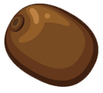
2. | 
3. | 
4. | 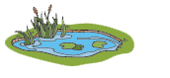
5. | 
B. Choose the right sentence.
6. | She’s sitting in the chair.
6. | a. |  | b.
7. | Is it in the pond?
7. | a. |  | b. | 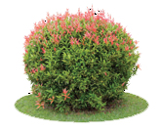

C. Match and make the right sentence.
8. |  | Is it | · |  | · a. some fresh kiwis.
9. |  | What’s your | · |  | · b. on the rock?
10. |  | We need | · |  | · c. sister doing?

First Nonfiction Reading Book 2
Review Test 3 (Unit 9-12)
Name | ___________________ | Score | __________ /_________

A. Match the words with the correct pictures.
1. | 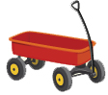 | · |  | · a. skunk
2. | 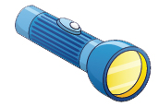 | · |  | · b. zebra
3. | 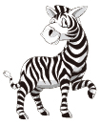 | · |  | · c. scissors
4. | 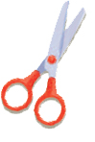 | · |  | · d. wagon
5. | 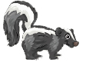 | · |  | · e. flashlight

B. Choose the right sentence.
6. | I am ready to color.
6. | a. |  | b.
7. | We should toast marshmallows.
7. | a. |  | b.

C. Match and make the right sentence.
8. |  | Pandas are | · |  | · a. my pencil
9. |  | I have | · |  | · b. black and white.
10. |  | We should | · |  | · c. make a campfire.
First Nonfiction Reading Book 2
Review Test 4 (Unit 13-16)
Name | ___________________ | Score | __________ /_________
A. Write the word with the correct picture.
flamingo
drum
hippo
robin
squirrel

1. | 
2. | 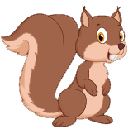
3. | 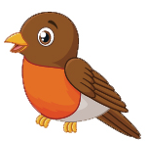
4. | 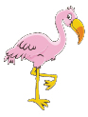
5. | 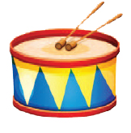
B. Choose the right sentence.
6. | They fly in the air.
6. | a. |  | b.
7. | Catch the ball.
7. | a. |  | b.

C. Match and make the right sentence.
8. |  | I can hear | · |  | · a. green alligator.
9. |  | Run on | · |  | · b. the whistle.
10. |  | That’s a long | · |  | · c. the ground.

First Nonfiction Reading Book 2
Review Test 1 Answer Key

Review Test 1
A. Match the words with the correct pictures.
1. c
2. d
3. b
4. e
5. a

B. Choose the right sentence.
6. b
7. b

C. Write the words in the order.
8. c
9. a
10. b

Review Test 2
A. Write the word with the correct picture.
1. kiwi
2. cherry
3. dish
4. pond
5. sister

B. Choose the right sentence.
6. a
7. a

C. Write the words in the order.
8. b
9. c
10. a

Review Test 3
A. Match the words with the correct pictures.
1. d
2. e
3. b
4. c
5. a

B. Choose the right sentence.
6. a
7. b

C. Match and make the right sentence.
8. b
9. a
10. c

Review Test 4
A. Write the word with the correct picture.
1. hippo
2. squirrel
3. robin
4. flamingo
5. drum

B. Choose the right sentence.
6. a
7. a

C. Match and make the right sentence.
8. b
9. c
10. a

