First Nonfiction Reading Book 2
Midterm Test (Unit 1-8)
Name | ___________________ | Score | __________ /_________
A. Match the words with the correct pictures.
1. | 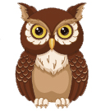 | · |  | · a. climbing net
2. | 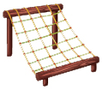 | · |  | · b. forest
3. |  | · |  | · c. special
4. | 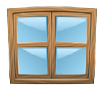 | · |  | · d. window

B. Write the right words.
side
bush
sharp
kiwi
5. | 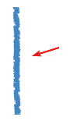 |  | 6. | 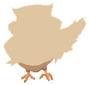

7. | 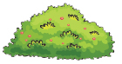 |  | 8. | 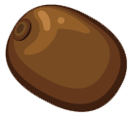
C. Choose the right sentence.
9. | 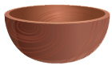 | The bowl get.
9. |  | Get the bowl.
10. | 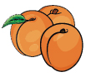 | I have some apricots.
10. |  | I have an apricot.

D. Write the words in the order.
11. | 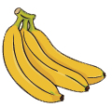 | are  Here  bananas.  some

12. | 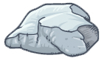 | on  the rock?  Is  it

13. |  | a  Let’s  draw  roof.

E. Read and answer
I lost my coin!
Where could it be?

Is it on the rock?
No, it is not there.

Is it behind the fence?
No, it is not there.

Is it under the bush?
No, it is not there.
Is it in the pond?
No, it is not there.

The coin is on the grass!
I found it!

Here it is!

14. What is the story about?
a. Eating a coin
b. Looking for a coin

15. Is the coin on the grass?
a. Yes, it is.
b. No, it isn’t
16. Is it in the _________? No, it is not.
a. pond
b. coin

First Nonfiction Reading Book 2
Midterm Test (Unit 1-8) Answer Key

A. Match the words with the correct pictures.
1. c
2. a
3. b
4. d

B. Write the right words.
5. side
6. sharp
7. bush
8. kiwi

C. Choose the right sentence.
9. |  | The bowl get.
9. |  | Get the bowl.
10. |  | I have some apricots.
10. |  | I have an apricot.

D. Write the words in the order.
11. Here are some bananas.
12. Is it on the rock?
13. Let’s draw a roof.

E. Read and answer
14. b
15. a
16. a

