First Nonfiction Reading Book 2
Final Test (Unit 9-16)
Name | ___________________ | Score | __________ /_________
A. Match the words with the correct pictures.
1. | 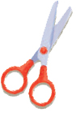 | · |  | · a. squirrel
2. | 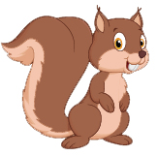 | · |  | · b. scissors
3. | 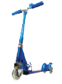 | · |  | · c. scooter
4. | 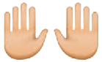 | · |  | · d. hands

B. Write the right words.
butterfly
hippo
crayon
panda
5. | 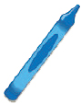 |  | 6. | 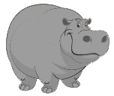

7. |  |  | 8. | 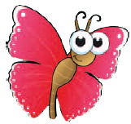
C. Choose the right sentence.
9. | 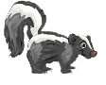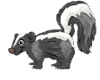 | Skunks are black and white.
9. |  | Skunk are not black and white.
10. | 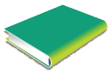 | I my book have.
10. |  | I have my book.

D. Write the words in the order.
11. |  | am ready  go to school.  I  to

12. |  | make  a campfire.  should  We

13. |  | you  Where do  worms?  see

E. Read and answer
Let’s go on a wild animal safari.

Look to the left. What’s that?
That’s a big black gorilla.

Look to the right. What’s that?
That’s a long green alligator.

Look to the left. What’s that?
That’s a huge gray hippo.
Look to the right. What’s that?
That’s a tall pink flamingo.

Let’s go look for some more animals.

14. What is the story about?
a. Animals in the sea
b. Animals in the wild safari

15. Is the hippo huge and gray?
a. Yes, it is.
b. No, it isn’t

16. Where can you see the tall pink flamingo?
a. Right
b. Left

First Nonfiction Reading Book 2
Final Test (Unit 9-16) Answer Key

A. Match the words with the correct pictures.
1. b
2. a
3. c
4. d

B. Write the right words.
5. crayon
6. hippo
7. panda
8. butterfly

C. Choose the right sentence.
9. |  | Skunks are black and white.
9. |  | Skunk are not black and white.
10. |  | I my book have.
10. |  | I have my book.

D. Write the words in the order.
11. I am ready to go to school.
12. We should make a campfire.
13. Where do you see worms?

E. Read and answer
14. b
15. a
16. a

