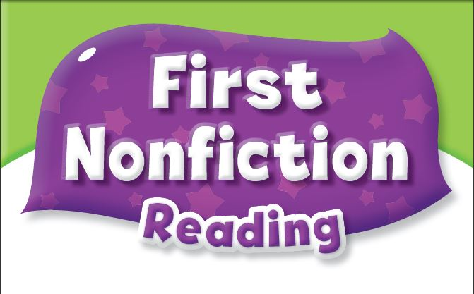


Answer Key

Unit 1 What Can You Draw?
Comprehension
1. | b. drawing
2. | a. triangle
3. | b. four sides
Key Words Practice
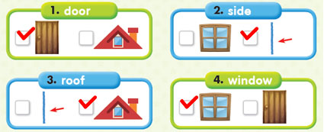
Sentence Practice
1. | 2-1-3 | Let’s draw a door.
2. | 1-3-2 | Let’s draw a window.
3. | 3-2-1 | Let’s draw a roof.

Unit 2 Let’s Travel
Comprehension
1. | a. nature
2. | b. Bears
3. | c. to the jungle
Key Words Practice
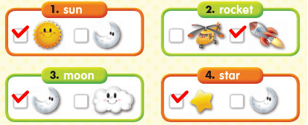
Sentence Practice
1. | 2-1-3 | We can see the sun.
2. | 3-1-2 | We can see the moon.
3. | 1-3-2 | We can see some stars.

Unit 3 Playtime at School
Comprehension
1. | a. a garden
2. | b. potatoes
3. | a. looks good
Key Words Practice
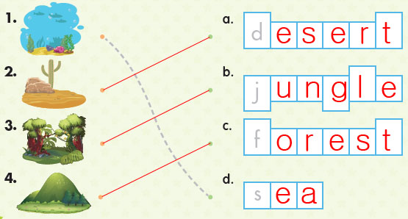
Sentence Practice
1. | b. Let’s travel to the desert.
2. | a. Let’s travel to the jungle.
3. | a. Let’s travel to the sea.

Unit 4 A Special Bird
Comprehension
1. | b. playtime
2. | b. monkey bars
3. | a. on the jungle gym
Key Words Practice
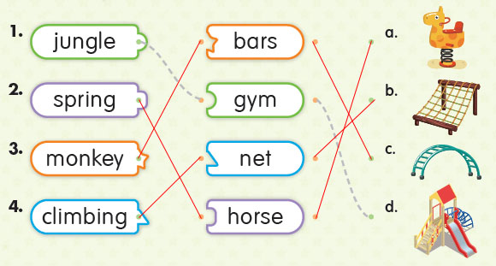
Sentence Practice
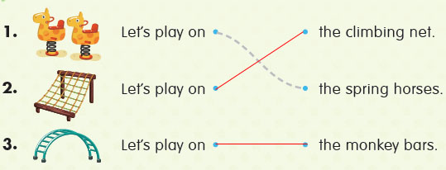

Unit 5 Where Is It?
Comprehension
1. | b. looking for a coin
2. | a. fence
3. | b. in the pond
Key Words Practice
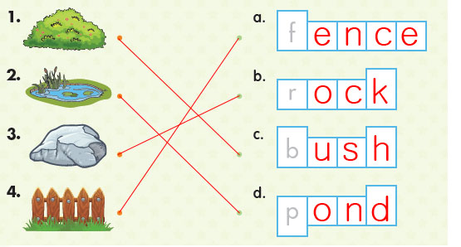
Sentence Practice
1. | a. Is it on the rock?
2. | b. Is it in the pond?
3. | a. Is it behind the fence?

Unit 6 Dinner Time
Comprehension
1. | a. dinner time
2. | b. forks
3. | b. is set
Key Words Practice
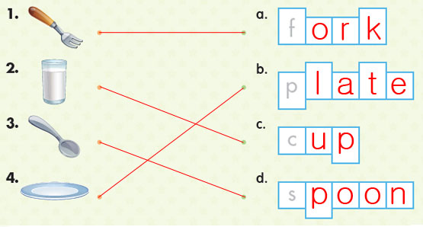
Sentence Practice
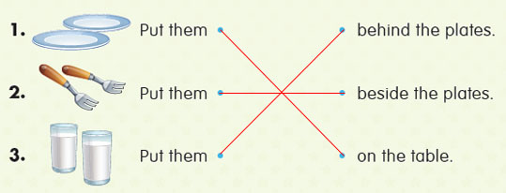
Unit 7 Fruit Salad
Comprehension
1. | a. a fruit salad
2. | b. cherries
3. | b. bite
Key Words Practice
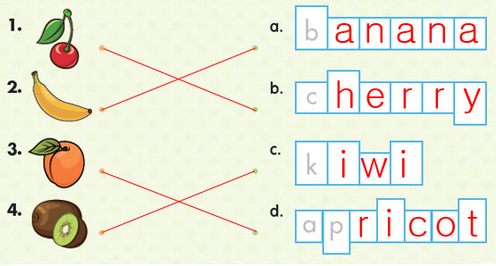
Sentence Practice
1. | 3-2-1 | We need some fresh kiwis.
2. | 2-1-3 | We need some fresh bananas.
3. | 3-1-2 | We need some fresh apricots.

Unit 8 Family Picnic
Comprehension
1. | a. a family
2. | b. dad
3. | a. sitting on the ground
Key Words Practice
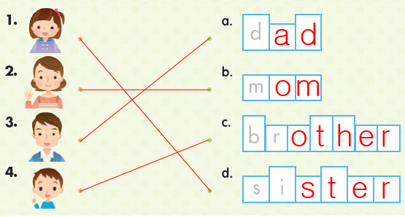
Sentence Practice
1. | b. He’s flying a kite.
2. | a. She’s playing with a ball.
3. | b. She’s sitting on a chair.

Unit 9 My Pet Dog
Comprehension
1. | b. black and white animals
2. | a. Cows
3. | a. my dog
Key Words Practice
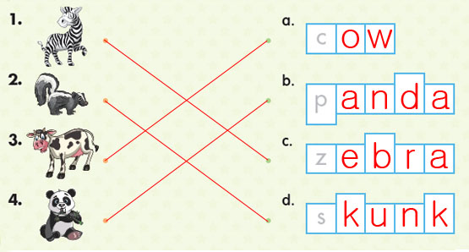
Sentence Practice
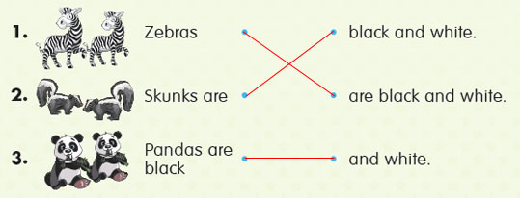
Unit 10 Push or Pull
Comprehension
1. | b. push or pull
2. | a. cart
3. | a. strong
Key Words Practice
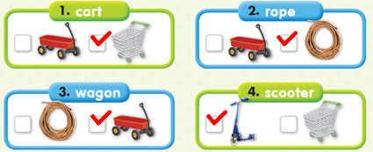
Sentence Practice
1. | 3-2-1 | We can push a scooter.
2. | 2-1-3 | We can pull a rope.
3. | 1-3-2 | We can pull a wagon.

Unit 11 Ready for School
Comprehension
1. | b. backpack
2. | b. book
3. | a. go to school
Key Words Practice
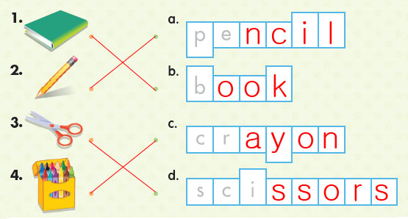
Sentence Practice
1. | b. I have my crayons.
2. | a. I have my book.
3. | b. I have my scissors.

Unit 12 Camping Trip
Comprehension
1. | b. campsite
2. | a. campfire
3. | a. in the tent
Key Words Practice
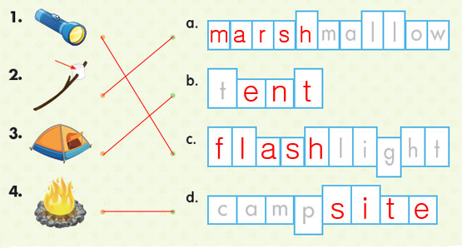
Sentence Practice
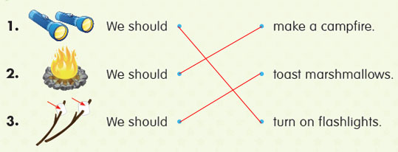
Unit 13 The Music Parade
Comprehension
1. | b. parade
2. | a. drums
3. | a. I can hear
Key Words Practice
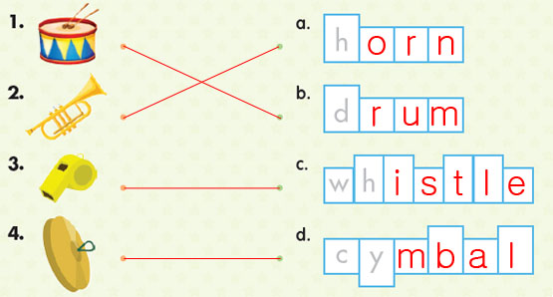
Sentence Practice
1. | 1-3-2 | I can hear the horns.
2. | 2-1-3 | I can hear the drums.
3. | 3-2-1 | I can hear the cymbals.

Unit 14 In the Forest
Comprehension
1. | a. forest
2. | b. worms
3. | c. Where do you see
Key Words Practice
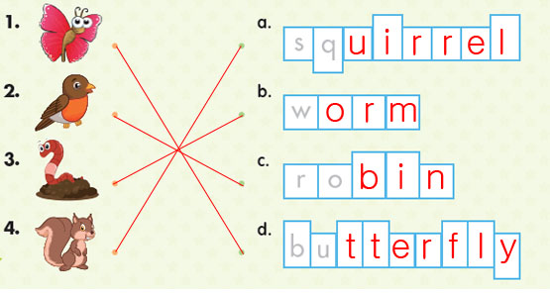
Sentence Practice
1. | a. They crawl in the dirt.
2. | b. They sit in the tree.
3. | b. They run on the grass.

Unit 15 Wild Animal Safari
Comprehension
1. | a. wild animals
2. | a. alligator
3. | a. big black
Key Words Practice
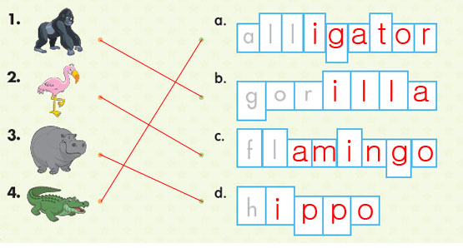
Sentence Practice
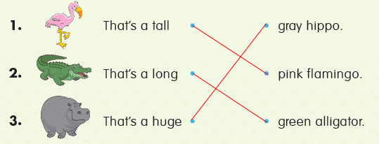
Unit 16 Let’s Play Basketball
Comprehension
1. | b. basketball
2. | a. with your hands
3. | a. Throw
Key Words Practice
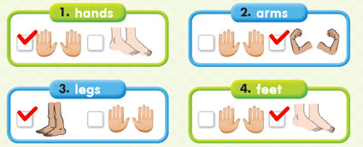
Sentence Practice
1. | 2-1-3 | You can catch with your hands.
2. | 3-1-2 | You can run with your legs.
3. | 1-3-2 | You can throw with your arms.

