First Nonfiction Reading Book 1
Midterm Test (Unit 1-8)
Name | ___________________ | Score | __________ /_________
A. Match the words with the correct pictures.
1. | 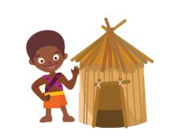 | · |  | · a. carrot
2. |  | · |  | · b. teepee
3. |  | · |  | · c. star
4. |  | · |  | · d. hut

B. Write the right words.
cream cake
short
potato
sun
5. |  |  | 6. | 

7. |  |  | 8. | 

C. Choose the right sentence.
9. |  | We can see the moon
9. |  | We the moon can see.
10. | 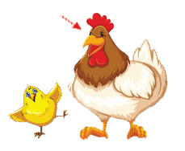 | This is a mother chicken.
10. |  | Mother chicken this is.

D. Write the words in the order.
11. | 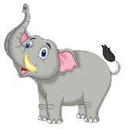 | is  The elephant  tall.  big and

12. | 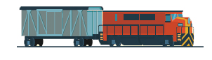 | on  the track.  They  go

13. | 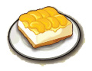 | I  please.  want  peach cake,

E. Read and answer
Where do planes go?
They fly in the sky.

Where do trucks go?
They go on the road.

Where do ships sail?
They sail on the sea.

Where do trains go?
They go on the tracks.

Buckle up and let’s go!

14. What is the story about?
a. Where the things go
b. Where we go

15. Do trucks go on the sea?
a. Yes, they are.
b. No, they aren’t.
16. Do trains go on the track?
a. Yes, they are.
b. No, they aren’t

First Nonfiction Reading Book 1
Final Test (Unit 9-16) Answer Key

A. Match the words with the correct pictures.
1. d
2. a
3. b
4. c

B. Write the right words.
5. cream cake
6. potato
7. sun
8. short

C. Choose the right sentence.
9. |  | We can see the moon
9. |  | We the moon can see
10. |  | This is a mother chicken.
10. |  | Mother chicken this is.

D. Write the words in the order.
11. The elephant is big and tall.
12. They go on the track.
13. I want peach cake, please.

E. Read and answer
14. a
15. b
16. a

