First Nonfiction Reading Book 1
Final Test (Unit 9-16)
Name | ___________________ | Score | __________ /_________
A. Match the words with the correct pictures.
1. | 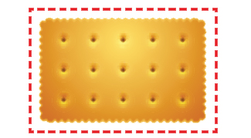 | · |  | · a. rectangle
2. | 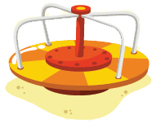 | · |  | · b. umbrella
3. | 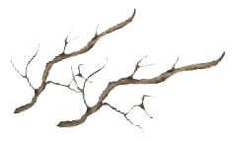 | · |  | · c. merry-go-round
4. | 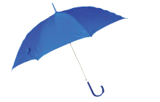 | · |  | · d. branches

B. Write the right words.
swing
fall
roots
spider
5. | 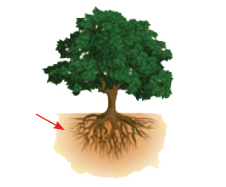 |  | 6. | 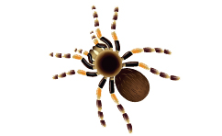

7. | 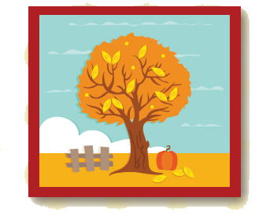 |  | 8. | 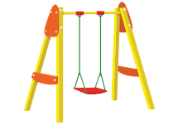
C. Choose the right sentence.
9. | 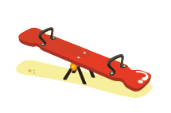 | I like to ride slide.
9. |  | I like to ride a seesaw.
10. | 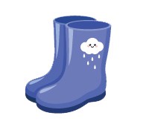 | I need my rain boots.
10. |  | I need that rain hat.

D. Write the words in the order.
11. | 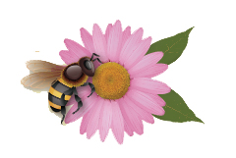 | is  It  the flower.  on

12. | 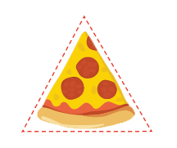 | shape  the pizza?  is  What

13. | 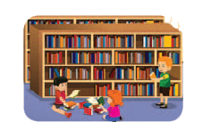 | She  to  goes  the library.

E. Read and answer
What’s in your pocket?

Is there a card in your pocket?
Yes, there is.

Is there a toy in your pocket?
Yes, there is.

Is there a candy in your pocket?
Yes, there is.

Is there a coin in your pocket?
Yes, there is.

Is there a frog in your pocket?
No way!

14. What is the story about?
a. Things in the pocket
b. Bugs in the pocket

15. Is a candy in the pocket?
a. Yes, It is.
b. No, It isn’t.
16. Is a frog in the pocket?
a. Yes, It is.
b. No way!

First Nonfiction Reading Book 1
Final Test (Unit 9-16) Answer Key

A. Match the words with the correct pictures.
1. a
2. c
3. d
4. b

B. Write the right words.
5. roots
6. spider
7. fall
8. swing

C. Choose the right sentence.
9. |  | I like to ride slide.
9. |  | I like to ride a seesaw.
10. |  | I need my rain boots.
10. |  | I need that rain hat.

D. Write the words in the order.
11. It is on the flower.
12. What shape is the pizza?
13. She goes to the library.

E. Read and answer
14. a
15. a
16. b

