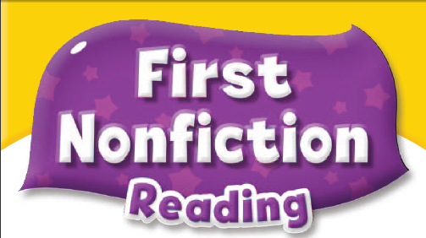


Answer Key

Unit 1 My Home
Comprehension
1. | b. my home
2. | b. hut
3. | a. round
Key Words Practice
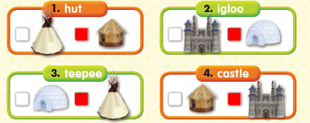
Sentence Practice
1. | a. My home is a castle..
2. | b. My home is a teepee..
3. | b. My home is a hut..

Unit 2 What’s in the Sky?
Comprehension
1. | a. sky
2. | a. rocket
3. | b. some stars
Key Words Practice
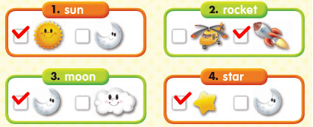
Sentence Practice
1. | 2-1-3 | We can see the sun.
2. | 3-1-2 | We can see the moon.
3. | 1-3-2 | We can see some stars.

Unit 3 My Garden
Comprehension
1. | a. a garden
2. | b. potatoes
3. | a. looks good
Key Words Practice
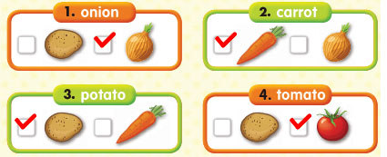
Sentence Practice
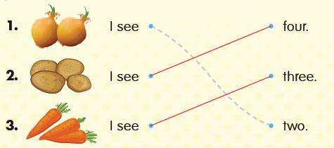
Unit 4 Animal Kids
Comprehension
1. | a. animals
2. | a. pups
3. | a. These are kids
Key Words Practice
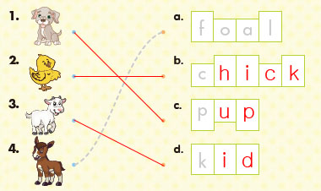
Sentence Practice
1. | b. These are foals.
2. | a. These are chicks.
3. | a. These are pups.

Unit 5 Big and Small
Comprehension
1. | a. big and small animals
2. | a. fast
3. | b. slow and small
Key Words Practice
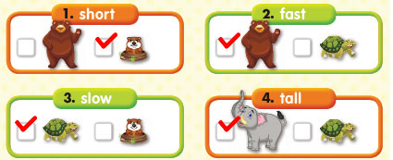
Sentence Practice
1. | 2-1-3 | The bear is big and fast.
2. | 3-2-1 | The gopher is short and small.
3. | 1-3-2 | The elephant is big and tall.

Unit 6 Birthday Cake
Comprehension
1. | b. cake
2. | b. want
3. | c. cream cake
Key Words Practice
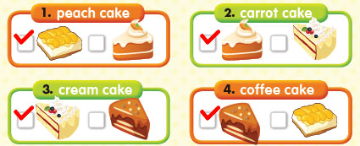
Sentence Practice
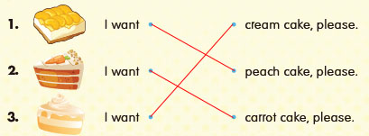
Unit 7 Let’s Go
Comprehension
1. | a. where things go
2. | b. planes
3. | a. They go on the road
Key Words Practice
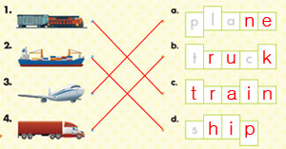
Sentence Practice
1. | a. They go on the tracks.
2. | b. They sail on the sea.
3. | a. They go on the road.

Unit 8 My Face
Comprehension
1. | a. face
2. | b. nose
3. | a. see
Key Words Practice
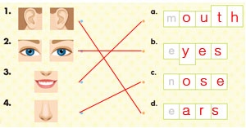
Sentence Practice
1. | 3-1-2 | I have a nose.
2. | 2-1-3 | I have ears.
3. | 1-3-2 | I have eyes.

Unit 9 I Like the Park
Comprehension
1. | a. the park
2. | b. slide
3. | a. ride the swing
Key Words Practice
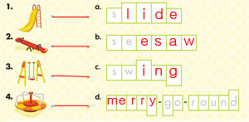
Sentence Practice
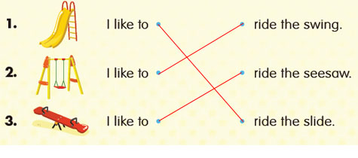
Unit 10 A Rainy Day
Comprehension
1. | b. rainy day
2. | a. boots
3. | a. outside
Key Words Practice
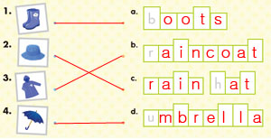
Sentence Practice
1. | a. I need my boots.
2. | b. I need my raincoat.
3. | b. I need my umbrella

Unit 11 Look Around
Comprehension
1. | a. bugs
2. | b. grass
3. | a. touch
Key Words Practice
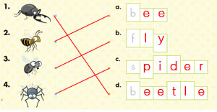
Sentence Practice
1. | 2-1-3 | It is on the ground.
2. | 3-1-2 | It is in the web.
3. | 1-3-2 | It is on the grass.

Unit 12 Fun with Food
Comprehension
1. | a. shapes
2. | b. pizza
3. | a. circle
Key Words Practice
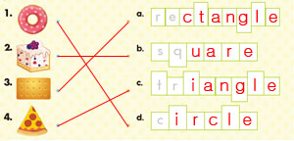
Sentence Practice
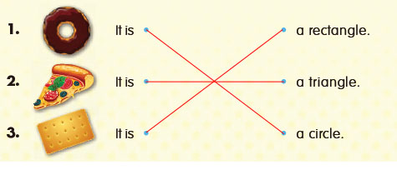
Unit 13 What’s in Your Pocket?
Comprehension
1. | b. pocket
2. | a. coin
3. | a. No way!
Key Words Practice
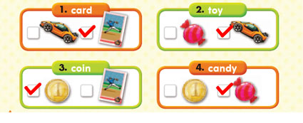
Sentence Practice
1. | a. Is there a candy in your pocket?
2. | b. Is there a coin in your pocket?
3. | b. Is there a card in your pocket?

Unit 14 What She Likes Doing
Comprehension
1. | a. doing things
2. | a. library
3. | b. swimming
Key Words Practice
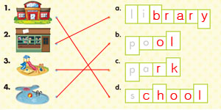
Sentence Practice
1. | 2-1-3 | She likes reading.
2. | 1-3-2 | She likes playing.
3. | 3-1-2 | She likes learning.

Unit 15 The Tree
Comprehension
1. | a. tree
2. | a. leaves
3. | a. roots
Key Words Practice
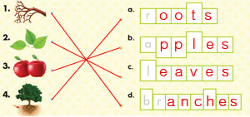
Sentence Practice
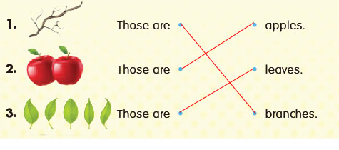
Unit 16 The Four Seasons
Comprehension
1. | a. season
2. | a. fall
3. | a. snowy and cold
Key Words Practice
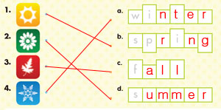
Sentence Practice
1. | b. It’s sunny and bright.
2. | b. It’s rainy and light.
3. | a. It’s snowy and cold.

